 | Adamova Gulden Hasenovna  Director of the Department of Youth Policy  Chairman of the Council  e-mail: guldenaa@mail.ru
 | Tilegenkyzy Sara  Methodologist at the Center for Patriotic and Legal Education of the DYP  Secretary of the Council  e-mail: niipatriot@ktu.edu.kz
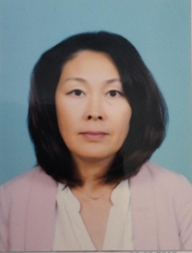 | Abilkassymkyzy Botakoz  Head at the Center for Patriotic and Legal Education of the DYP  Member of the Council  e-mail: niipatriot@ktu.edu.kz
 | Tusupbekov Abaydolda Saipashevich  Deputy Dean for educational work of ACF  Member of the Council  e-mail: abaydolla@mail.ru
 | Kakenova Meruert Zhambulovna  Deputy Dean for educational work of MF  Member of the Council  e-mail: meruertkakenova@mail.ru
 | Nessipbaeva Nazym Erzhanovna  Deputy Dean for educational work of MMEF  Member of the Council  e-mail: Neesipbaeva@mail.ru
 | Ospangalieva Mendykul Tuleutaevna  Deputy Dean for educational work of FTLaЕЕ  Member of the Council  e-mail: omendikul@mail.ru
 | Sagatbekova Dinara Ermekovna  Deputy Dean for educational work of ITF  Member of the Council  e-mail: dinara.sagatbkova@mail.ru
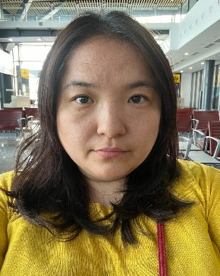 | Abilzhanova Fariza Bolatovna  Deputy Dean for educational work of PEA&TF  Member of the Council  e-mail: Fariz-90@mail.ru
 | Aserbayeva Dinara Maratovna  Deputy Director for еducational work of CIT  Member of the Council  e-mail: e-mail: Aserbayevadinara@gmail.com

